User Documentation: Banking Management System

1. Introduction

2. Home Page

3. Admin

3.1 Admin Dashboard

3.2 Employee registration

3.3 Employee List

3.4 Edit Employee

3.5 Search Employee

3.6 Delete Employee

4. Employee

4.1 Employee Dashboard

4.2 Customer Registration

4.3 Customer List

4.4 Edit Customer

4.5 Search Customer

4.6 Delete Customer

5. Customer

5.1 Customer Dashboard

5.2 Customer Login

5.3 View Customer Details

5.4 Edit Personal Detail

5.5 Withdraw Amount

5.6 Deposit Amount

5.7 Transfer Amount

5.8 Check Balance

1. Introduction

The Bank Management System is a web-based application built with JSP, Java Servlets, and Apache Derby, designed to manage employees and customers efficiently. It features role-based access for Admin, Employee, and Customer, each with distinct permissions.

Admins can manage employees and view customer details, employees can access customer information, and customers can view their account details. The system includes a structured database schema, secure authentication, and form validation to ensure data integrity. With CRUD operations and a user-friendly interface, it provides a secure and efficient solution for bank management.

2. Home Page

* The homepage provides options to log in as Admin, Employee, or Customer.
* After successful login, users are redirected to their respective dashboards based on their roles.
* Additionally, there is an option for new users to register before logging in.

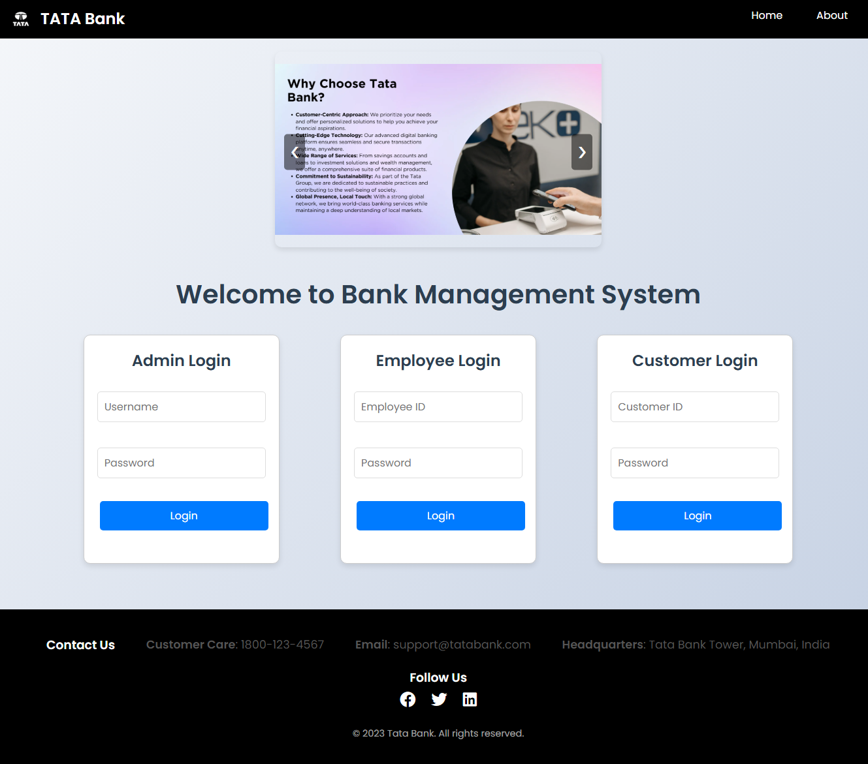

3. Admin

3.1 Admin Dashboard

* The menu includes various options such as Create Employee, View Employee by ID, View All Employees, Update Employee, and Delete Employee by ID.

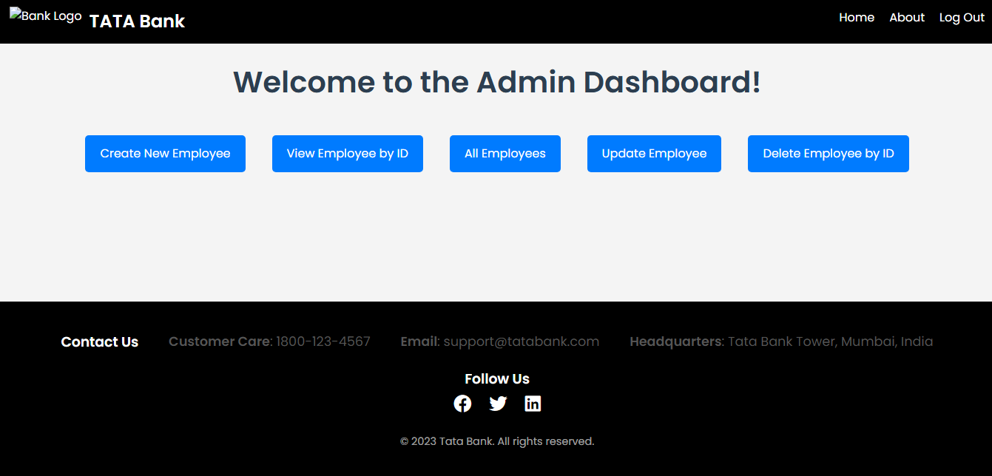

3.2 Employee registration

The Admin can register a new Employee by entering their details.

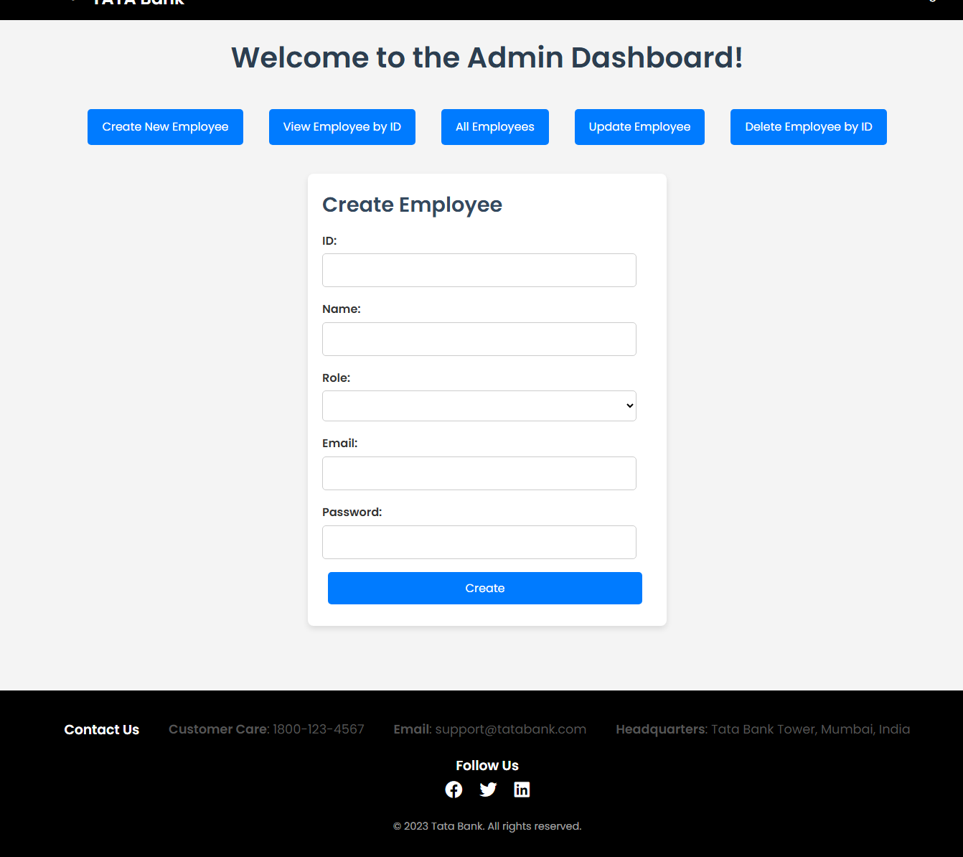

3.3 Employee List

The Admin can view a list of all employees along with their details.

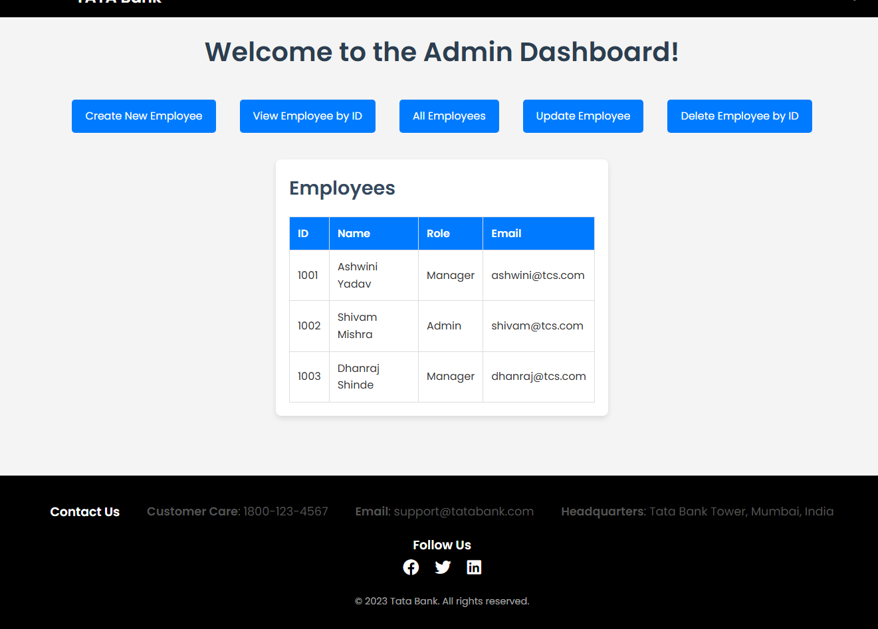

3.4 Edit Employee

The Admin can update an employee's details by searching for their Employee ID.

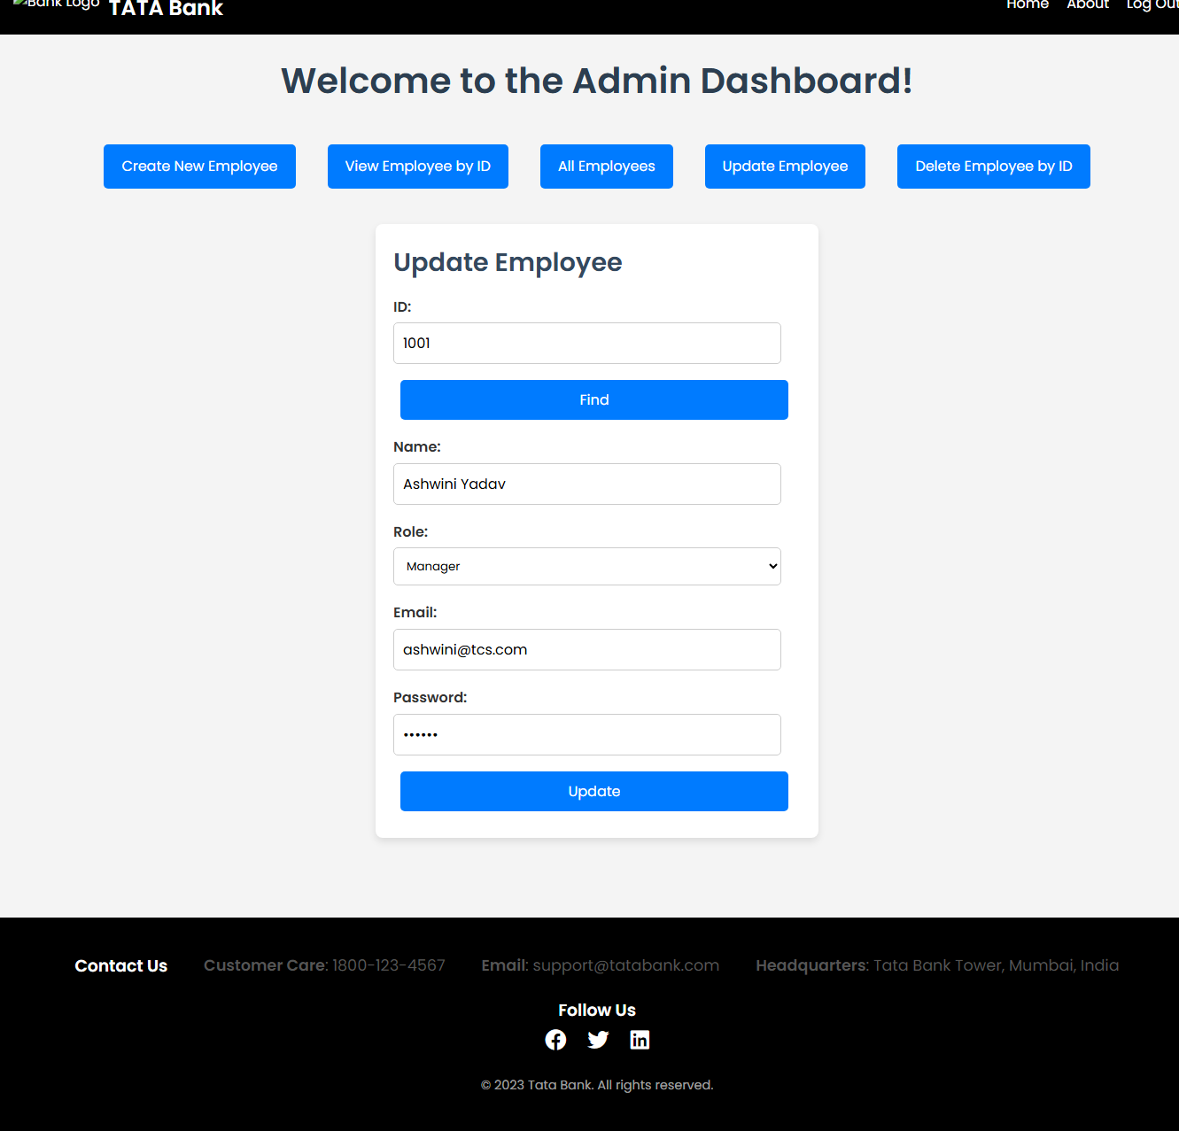

3.5 Search Employee

Admin can find employees by using their Employee ID

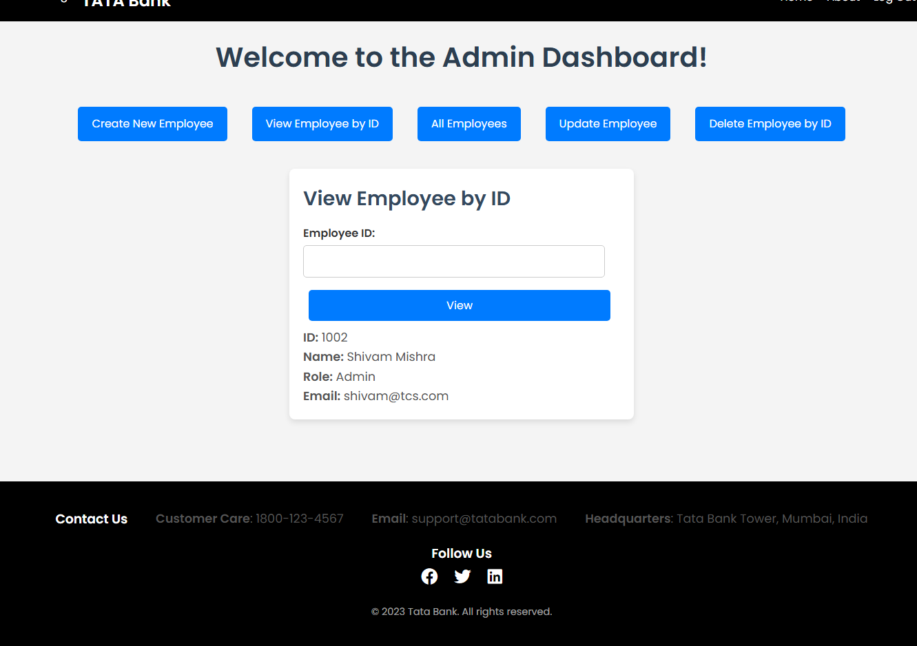

3.6. Delete Employee

Admin is able to delete Employee by their Employee Id

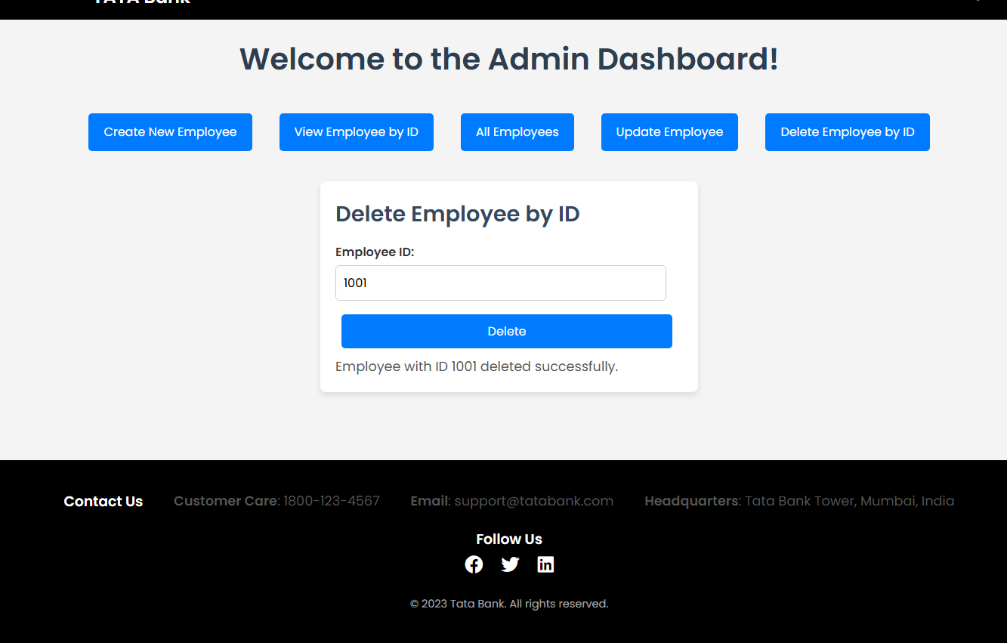

4. Employee

4.1 Employee Dashboard

* Employee Dashboard has a menu
* The menu includes various options such as Create Customer, View Customer by ID, View All Customers, Update Customer, and Delete Customer by ID.

4.2 Customer Registration

The Customer can register a new Customer by entering their details.

4.3 Customer List

The Employee can view a list of all Customers along with their details.

4.4 Edit Customer

The Employee can update a customer’s details by searching for their SSN ID.

4.5 Search Customer

Employee can find customers by using their SSN ID

4.6 Delete Customer

Employee is able to delete Customer by their Customer Id

5. Customer

5.1 Customer Dashboard

The Customer Dashboard provides access to various banking services.

5.2 Customer Login

Customers can securely log in using their credentials to access their accounts.

5.3 View Customer Details

Customers can view their personal details and account information.

5.4 Edit Personal Detail

Customers can update their personal information, such as address and contact details.

5.5 Withdraw Amount

Customers can withdraw money from their accounts securely.

5.6 Deposit Amount

Customers can deposit funds into their accounts.

5.7 Transfer Amount

Customers can transfer money to other accounts within the bank.

5.8 Check Balance

Customers can check their account balance in real-time.